Response Time and Turning Angle Test

Integration of Motors and Proximity Sensor

by Göksenin Hande Bayazıt & Taha Dogan

Dec. 17, 2017

# Test Conditions

* Location: Design Studio
* Date: Dec. 17, 2017
* Ambient Temperature: Room temperature (appx. 23-25◦C)
* Environment: Loud, luminous
* Measure: Turning time and turning angle
* Measurement Tools: Protractor, ruler, pencil

# Test Procedure

This test aims to observe the behavior of integration of two subsystems, which are motors and proximity sensor.

In the previous tests, we have observed successive results. In this test, the turn angle corresponding to different run times of the code that performs turning to right. Two subsystems integrated on Raspberry Pi 3. The scenario is that the robot continues on its route until it encounters an obstacle, in fact in our case a wall, and turns right first due to Standard Committee Regulations.

The test is performed as follows: The run time of the code is set to different values in order to observe corresponding turning angles of the tyres. Starting point of the vehicle, the point that the vehicle senses the obstacle and stops, the point after the vehicle turns right and stops and the final point that the vehicle stops are marked. These four points form two approximately perpendicular lines and the angle between them is measured with a protractor. This setup is shown in Figure 1, below.

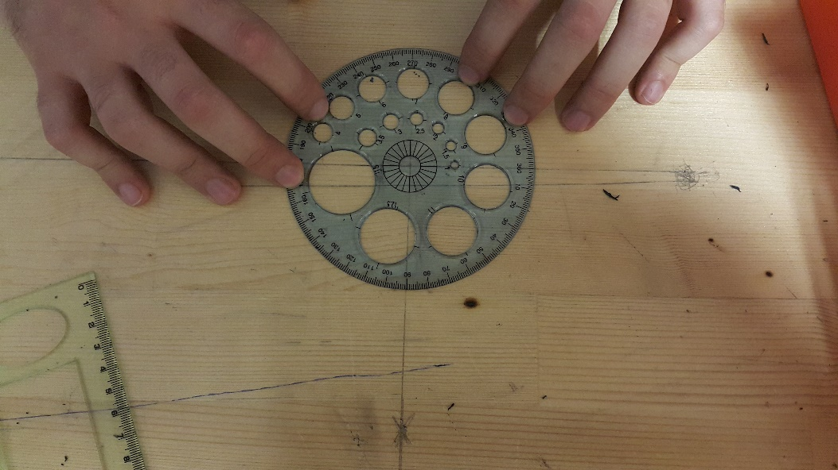

Figure 1: Experimental Setup

# Test Results

**3.1 Specifications**

* Power Supply to motors, constant: 8 Volts
* Controller RP3
* Motor drive: L298P Shield

**3.1.2 Measurement Results:**

Test results are provided on Table 1, below.

Table 1: Turn Angles Corresponding to Different Right-Turn Run Times

|  |  |  |  |
| --- | --- | --- | --- |
| **Run Time** | 0.5 sec | 0.4 sec | 0.45 sec |
| **Trial 1** | 104 o | 85o | 88o |
| **Trial 2** | 93 o | 86 o | 83 o |
| **Trial 3** | 103 o | 80 o | 90 o |

# Conclusion

These tests are performed in order to observe integrated system response. As can be seen above, proximity sensor reacts very quickly. The time required to turn robot approximately 90⁰ takes around 0.45 sec. However, please note that there is not neither gearbox in motor setup nor speed control software. Thus, motors are run at top speed at given voltage.